Document of JDBC
Prepared By: Garun Mishra
Date:2017-03-31

Java Database Conenctivity:
=> Java Database Connectivity is a technology that enable the java programmer to connect database and manipulate the data.
=>JDBC is a java application programming interface that allow the java Java programmer to access database management system from java code.
=>JDBC is a java API which enables the java programs to execute the SQL statement.
=>It is an application programming interface that defines how a java programmer can access the database.
=>The java application programming interface provides a mechanism for dynamically loading the correct Java packages and drivers and registering them with the JDBC Driver Manager that is used as a connection factory for creating JDBC connection which support creating and executing statments such as SQL. INSERT, UPDATE, and DELETE. DriverManager is the backbone of the JDBC architecture.
=>JDBC is similar to Open Database Connectivity(ODBC)which is used for accessing and managing databse, but difference is that JDBC is design specially for Java programs, where as ODBC is not depend upon any language.
=> What JDBC Do?
i) It helps to connect to the database.
ii) It helps to executes
iii) Retrieving and processing the result received from the database in terms of answering to your query.
=> There are three main steps to acces Data Base using JDBC:
i)Load JDBC Driver for Database. If you want to connect ORACLE then you have to load ORACLE Driver. If you MySQL then MySQL Driver.
ii)Get connection from the DriverManager.
iii)Execute the Query and access the result.
=>JDBC Architecture:
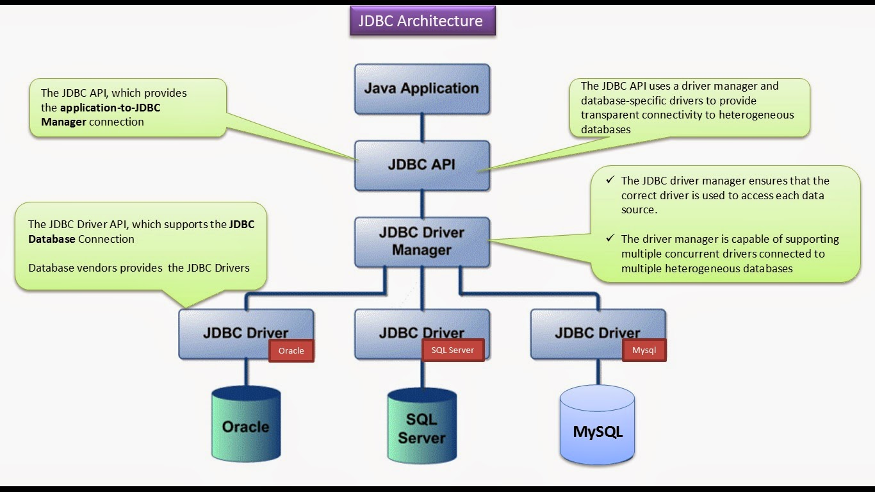
JDBC is core part of Java plateform and is included in the standard JDK distribution. The purpose of JDBC is to connect Database and manipulate the data in Data Base. The main component of JDBC are :
->Connection Interface.
-> Statement interface
->ResultSet interface
->PreparedStatement interface.
->CollableStatement
->Driver Class
->DriverManager Class.
=>Difference between Statment, PreParedStatement and CollableStatement:
->These are the interface.
->Statement is used to execute normal SQL Queries, PreparedStatement is used to execute parameterized or dynamic SQL Queries and CollableStatement is used to call Stored Procedure.
->Statement is preferable when when a particular SQL Query is to be executed only once , Prepared Statement is preferable when a particular query is to executed multiple times. And CollableStatement is preferable when the Stroed procedure is to be executed.
->You cant pass the parameters to the SQL query using intefrace in Statement, In PreparedStatement you can pass the parameters to SQL query at runtime using interface, and In the CollableStatement you can pass three type of parameters using the interface. They are IN,OUT and IN-OUT.
->Statement interface is mainly used for DDL Statement like CREATE, ALTER, DROP etc, PreParedStatment is used for any kind of SQL queires which are to be executed multiple times and CollableStatement interface is used to execute stored procedures and functions.
->The performace of Statement is very low, The performance of PrepareStatement interface is better than Statement interface(When used for multiple execution of same query), The performance of CollableStatement interface is high.

=>JDBC Drivers
->JDBC defines how a java appllicaion communicate with datatbase. JDBC API has two major packages java.sql and javax.sql.
->There are four types JDBC drivers available:
i- Type 1 driver – the JDBC-ODBC bridge.
ii – Type 2 Driver – The Native API Drivers
iii – Type 3 Drivers – The network protocol drivers
iv - Tyep 4 Drivers – The native protocol drivers
->Type 1 driver – the JDBC-ODBC bridge: It is a database driver implementation that the ODBC driver to connect to the database. The driver converts JDBC method calls into ODBC function calls. This bridge is used when there is no pure-java driver available for a particular database.
The driver is implemented in sun.jdbc.odbc.JdbcOdbcDriver class. The driver is plateform dependents as it makes use of ODBC which in turn depends on native libraries of the operating system.
Advantage:
a. Almost any database for which ODBC driver is installedc can be accessed.
Disadvantage:
a. Performance overhead since the calls have to go through the JDBC Overhead bridge to the ODBC driver.
b. The ODBC driver needs to be installed on the client machine.
c. Considering the client-side software needed, this might not be suitable for applets.
->Type 2 Driver – The Native API Drivers: It is a database driver implementation that uses the cleint side libraries of databse. The driver converts the JDBC method calls into native calls of database API. This driver is not written entirely in Java as it interface with non-java code that makes the final database calls. A native API partly Java technology-enabled driver converts JDBC Calls into calls on clients API for ORACLE, DB2 or others. Note that, likly the bridge driver , this style of driver requires some binary code be loaded on each client machine.
However, this driver provides more functinality and performance that the JDBC-ODBC bridge driver as it doesnt have the overhead of the additional ODBC function calls.
Advantage:
Better performance that type I driver since no jdbc to odbc translation is needed.
Disadvantage:
a. The vendor client library needs to be installed on the client machine.
b. Can not be used in internet due the client software needed.
c. Not all database give the client side library.
->Type 3 Drivers – The network protocol drivers: It is a database driver implementation which makes use of a middle tierbetween the calling program and the databse. The middle tier(Application layer) converts JDBC Calls directly or indirectly into vendor specific database protocol.
Advantage:
a. Since the communication between the cleint and middleware server is database independent, there is no need of vendor db library on the client machine.
b. The middleware server(can be full fledge J2EE Application Server) can provide typically middleware service like caching(connections, query, results, and so on), loading balance.
Disadvantage:
a. Requires database specific coding to be done in the middle tier.
b. An extra layer added may result in a time-bottleneck.
->Tyep 4 Drivers – The native protocol drivers: It is a database driver implememntation that converts JDBC calls directly int to the vendor specific datatbase protocol. The type 4 driver is written completely in java and is hence plateform independent. It is installed inside the JVM of client. It provides better performance over the type1 and 2 driver as It doesn't have the overhead of conversionof calls into ODBC or database API calls. Unlike the type 1 and 2 drivers, it doesn't need to associated software to work.
Advantage:
a. These driver dont translate the requests into db request to ODBC or pass it to client API for the db, nor do they need a middleware layer for request indirection. Thus the performance is considerable improved.
b. Web application mainly used this driver.
Disadvantage: At cleint side, a seperate driver is needed for each database. Ex-classes12.zip(for ORACLE)
=>JDBC Driver Manager:
-> The main responsibility of JDBC driver is to load all the drivers found in system properly as well as to select the most appropriate driver from opening a connectio to the database. The Driver Manager also helps to select the most appropriate driver from the previously loaded drivers when a new open database is connected.
Following are the steps happing inside to get connection.
Step1: Class.forName(“com.mysql.jdbc.Driver”); load the Driver.
Step2: In the com.mysql.jdbc.Driver class there is a static block, that will be execute first because of static block.
Static{
try{ DriverManager.registerDriver(new Driver()); } catch(SQLException)
{ throw new RuntimeException(“Can't register driver!”);}
}
The static block call the DriverManager.registerDriver(new Driver);
Step3: Inside the registerDriver().
Public static synchronized void registerDriver(java.sql.Driver driver)throw SQLExcetion {
DriverInfo di = new DriverInfo();
di.driver = driver;
di.driverClass = driver.getClass();
di.driverClassName = di.driverClass.getName();
driver.addElement(di);
println(“register Driver : ”+di);
}
DriverManager Class create a vector name driver and add the driver class to vector. Now in the vector we have com.mysql.jdbc.Driver object.

step4: to get connection we can have getConnection method.
Connection con = Drivermanager.getConnection(“jdbc:mysql://localhost:3306/testDB”, “Username”, “password”);
In this method, It search the driver in vector if available then connect and return connection.
for(int i=0; i<driver.size();i++){
DriverInfo di = (DriverInfo) driver.elementAt(i);
// if ?jdbc:mysql? keywork withic in input , match with the driver in the vector
vector{
Connectio result = di.driver.connection(url, info);
}
retrun connection;
this class geting url as input. The class check for the driver based on ?jdbc:mysql? In this case and connect driver.

-> The DriverManager class works between the user and the drivers. The task of DriverManager Class is to keep track of drivers that are available and handles establishing a connection between a database and the appropriatedriver. It even keep track of driver login time limits and printing a log database and appropriate driver. The class is mainly useful for the simple application, the most frequently used method of class is DriverManager.getConnection(). We can know by the name of the method that this methid establishes a connection to the database.
->The DriverManager maintains the list of Driver classes. Each driver has to be get registered in Drivermanager class by calling registerDriver method. By calling Class.forName(), the driver get autmomatically loaded.
-> Some of the methods is given as follows:
i) deregisterDriver(Driver d);
ii) registerDriver(Driver d);
iii) getConnection(String url) : It tries to establish the connection to a given database url.
iv) getConnection(String url, String user, String password):
v)getConnection(String url, Properties info)
vi) getDriver(String url): It attempts to locate the driver by the given string.
Vii) getDrivers(): It retrieves the enumeration of the drivers which has been registered with the DriverManager class.

:Garun Kumar Mishra

